You’re So Dramatic!!!!!!!

By: Rebecca Sara Coffey

What I want to sell online: I will be selling a Reality TV streaming service.
What model would I use, and why? I would be using the selling a service business model because I would be making a Reality TV streaming service. I believe this would be a fantastic service for reality TV addicts
My target audience will be Reality TV fans. You can watch and love reality TV at any age, and you can be a part of any demographic. Some people love Reality TV while others hate it. Some people hide that they like Reality TV. I know a lot of people who watch Reality TV with their children. It just all depends on what you are okay with your young children watching.

Business Model
What is You're So Dramatic!!!!!!? You're So Dramatic will be a Reality TV streaming service that will provide viewers with Reality TV shows from the past, present, and future that are aired worldwide.
Why I wanted to make, You're So Dramatic!!! I am a huge Reality TV fan, and most of the Reality TV shows I watch are on MTV. I cannot watch these shows because I do not have a cable TV provider. I wanted to make this company because I was annoyed that I could not watch my favourite Reality TV shows on MTV without a cable subscription. You might be asking why won't you get Hulu and watch them there. I have Hulu account, but Hulu only has past seasons of Catfish, The Hills, and Jersey Shore. MTV has other Reality TV shows on its network, and those shows are not on Hulu. Also, MTV will only let you watch without a cable provider once for 24hrs per device. So, you are probably wondering how I watch my favourite shows while I pay $1.99 or more a week on YouTube to watch episodes from Reality TV shows made by MTV, and that adds up. All my proof is down below.

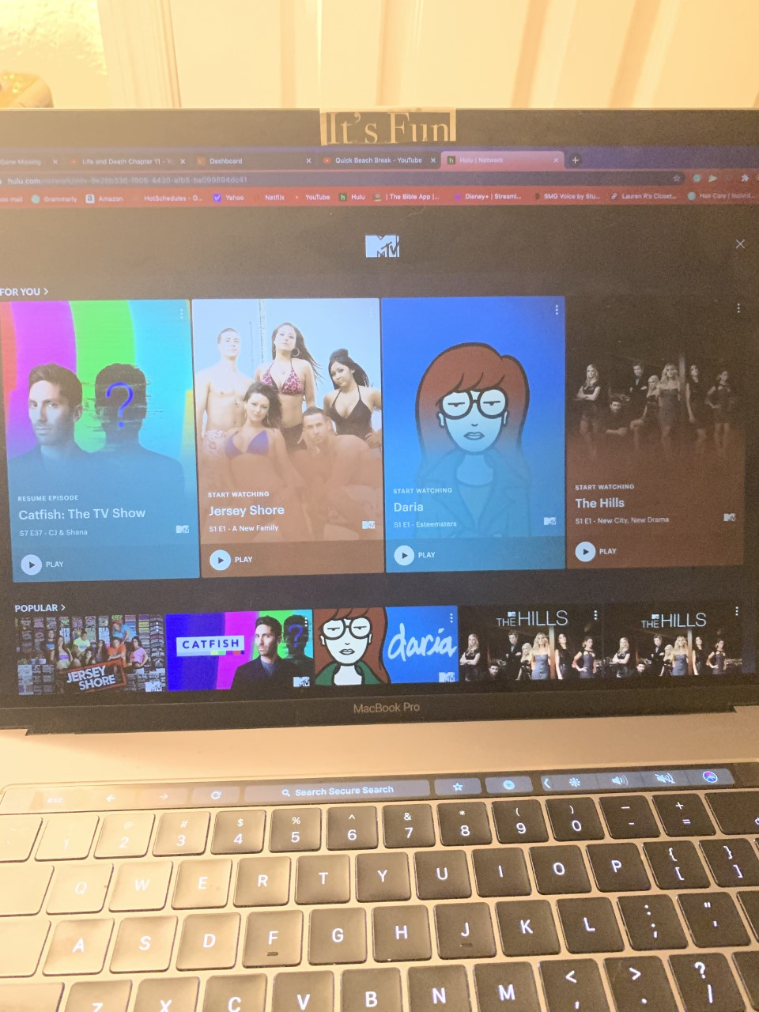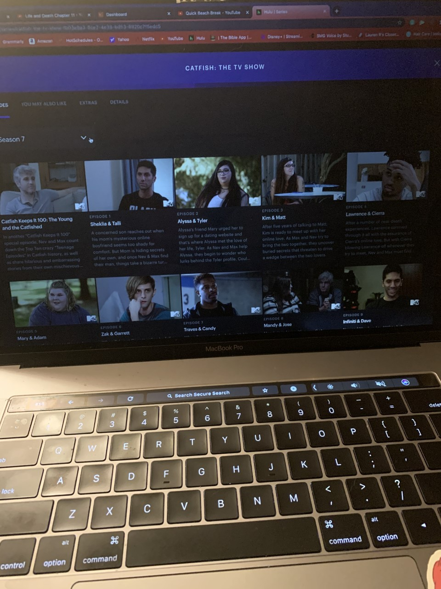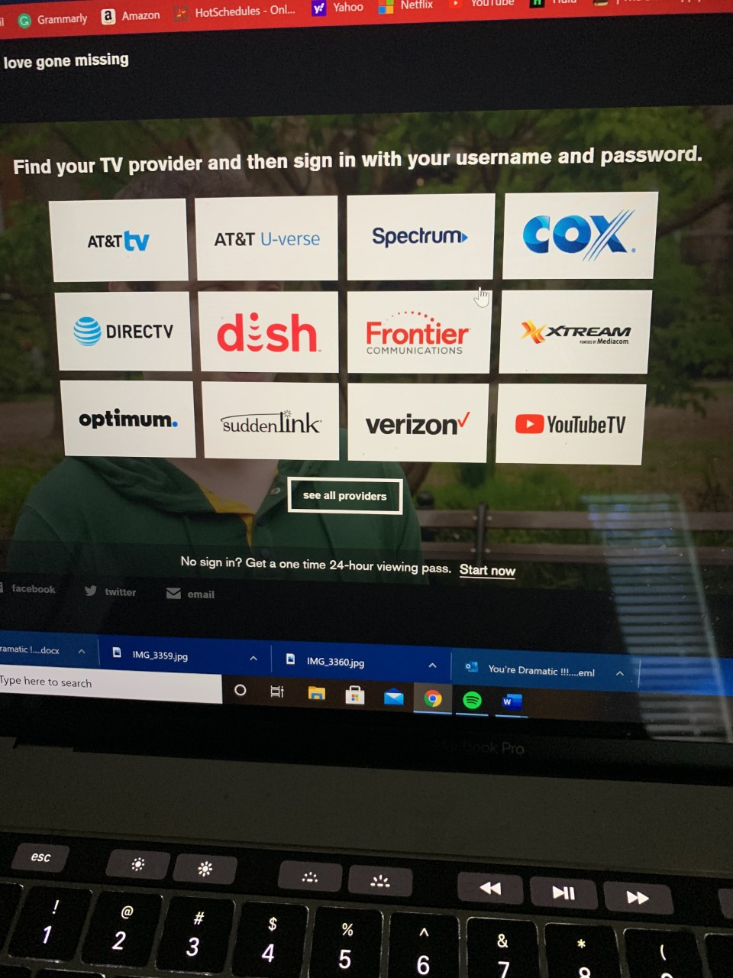
Selling Pitch: Yes, I know there are many streaming services out there, but there is no one out here that only has Reality TV Shows. My company will be like Shudder, but the difference will be is that it will be for Reality TV fans. I know many people hate paying a lot of money for cable, and I also know that cable companies and TV networks have issues with each other sometimes—for example, CBS and Direct TV.
With You're So Dramatic, you can access your favourite Reality TV shows from all over the world no matter where you live. Unlike Hulu You're So Dramatic won't need your location. You can watch all your favourite Reality TV shows no matter what countries they are isn't that great. For example, if you live in Australia and want to watch Celebrity Big Brother UK, you will be able to watch it because you have the You're So Dramatic streaming service. With this service, you can watch any Reality TV show the day after it airs on cable TV. You're So Dramatic will cost $5 per month. This service will also have a DVR section. If you want to watch a Reality TV show live and have no ads, it will cost you an extra $10. If you are a Reality TV lover, this platform is for you. Remember, you can leave at any time you want to, and the first week will be completely free.

How I Started: First, I had to think of the name I would call my streaming service. Once I came up with the name of my streaming service, You're So Dramatic, I had to look up if You're So Dramatic was taken, and once I saw it was not used, I knew I could continue using You're So Dramatic as the name for my streaming service for this assignment. After I knew I could make You're So Dramatic the name of my company, I looked up how I wanted my logo and name to look on my website.
I decide to have You're So Dramatic in the font of Parchment with the word You're So Dramatic in the colour red and highlighted in yellow with each letter in a different size, you will see a reflection of You're So Dramatic underneath, and with an exclamation mark at the end. If I were going to create this streaming service today, I would register You're So Dramatic as my company to be legally my company. Picture of my company's logo

You’re So Dramatic!!!!!!!

My plan: I first want to put every Reality TV show on MTV on my streaming service. MTV would the first company I would make a contract with. Once my platform becomes popular, I would contact other TV companies who have Reality TV shows and make contracts with them to put their shows on my streaming service. Every month I will be putting up new and old Reality TV programs that are on cable TV worldwide until every Reality TV show is on, You're So Dramatic. So, no matter where you are from around the world, you can watch every reality TV show that has ever been made no matter where you are from. I believe that this is amazing, and I also think that many people will make a subscription.
To conclude, the product I would be making is a Reality TV streaming service for people who love or love to hate watching Reality TV. There are Reality TV programs like Big Brother and Survivor that are appropriate and fun to watch with your entire family. Just because many Reality TV can be overdramatized, that does not mean that the whole family can't sit around the couch and watch it. Reality TV is not only for women and people who are 13 or older. Reality Tv can be for the entire family,

